Case Study Submission Template

- Name : Rajesh Losetty

- Employee Id : 389543

- Email Id : losetty.rajesh@tcs.com

- Your Git Repository URL : https://github.com/losetty143/batch10.git

- Attach the screenshot of your Dockerfile

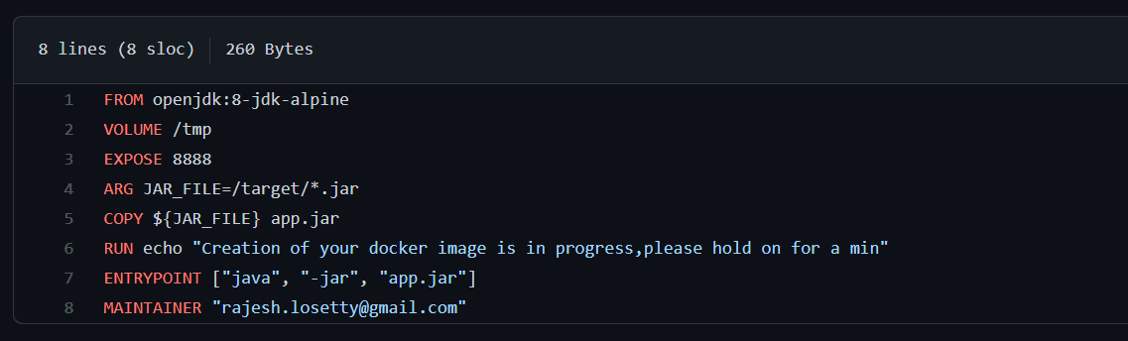

- Attach the screenshot of your Jenkinsfile.
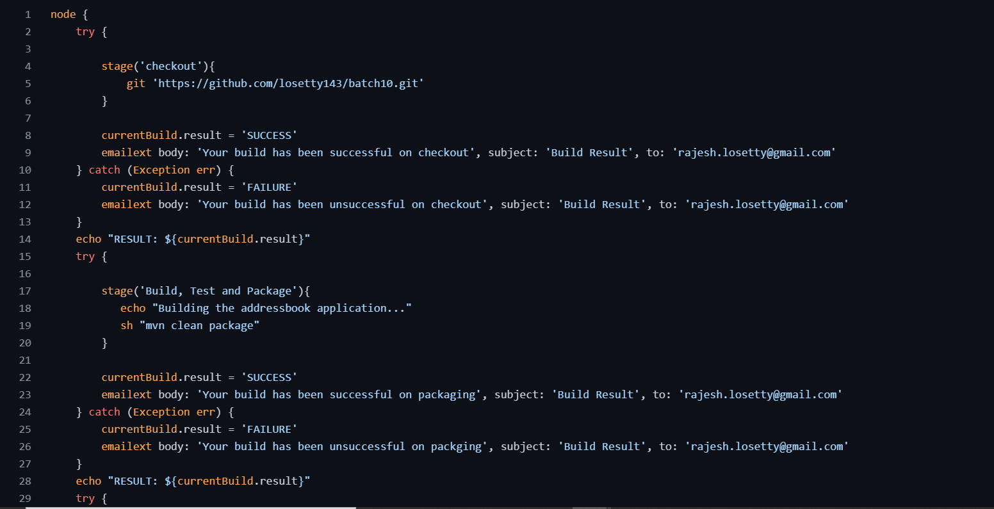

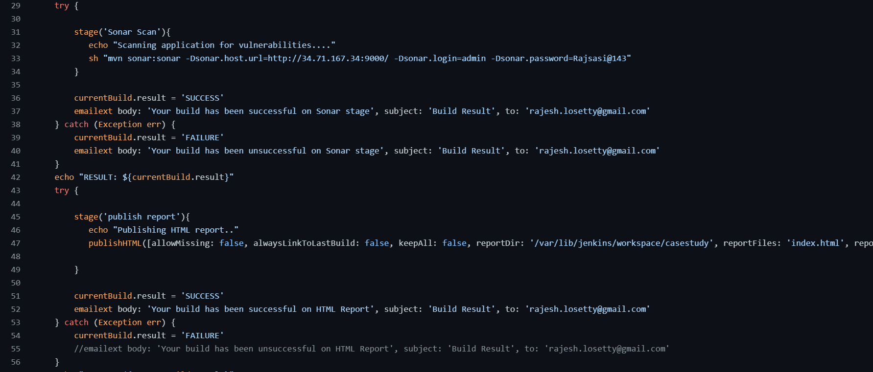
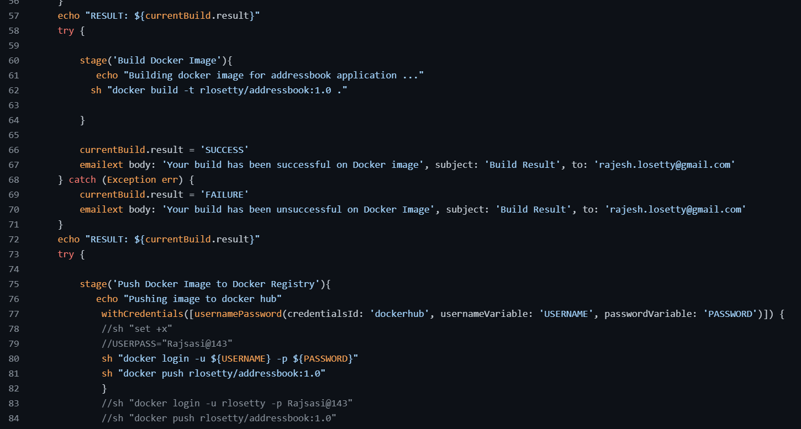
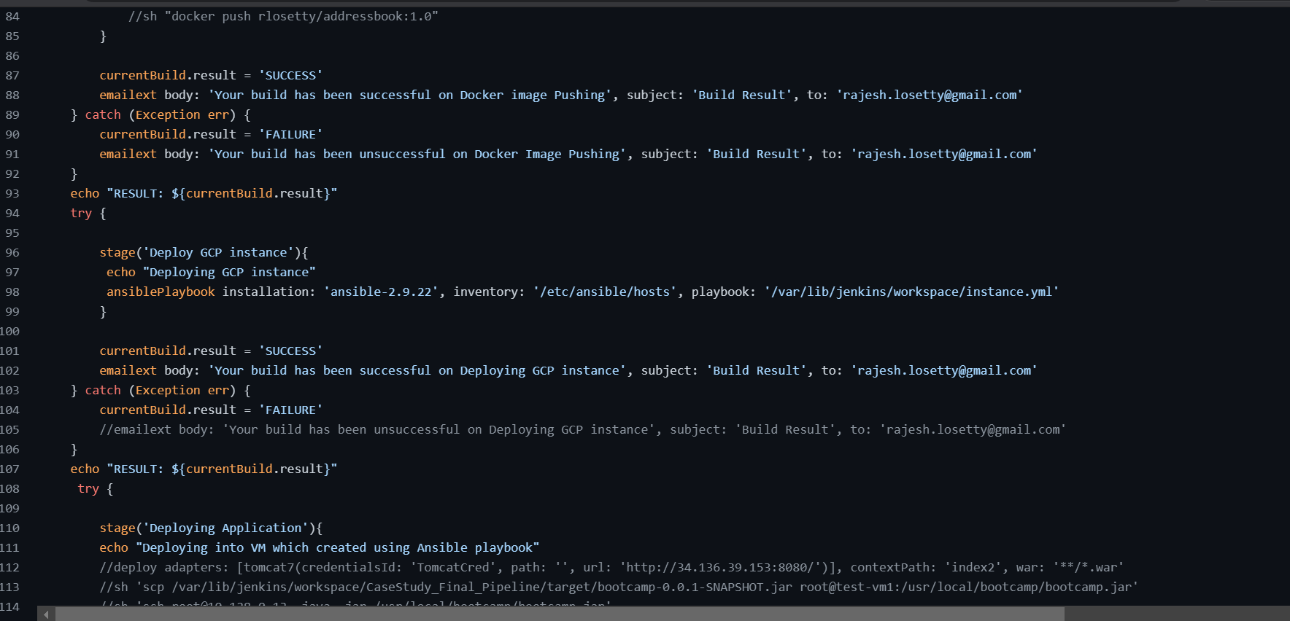
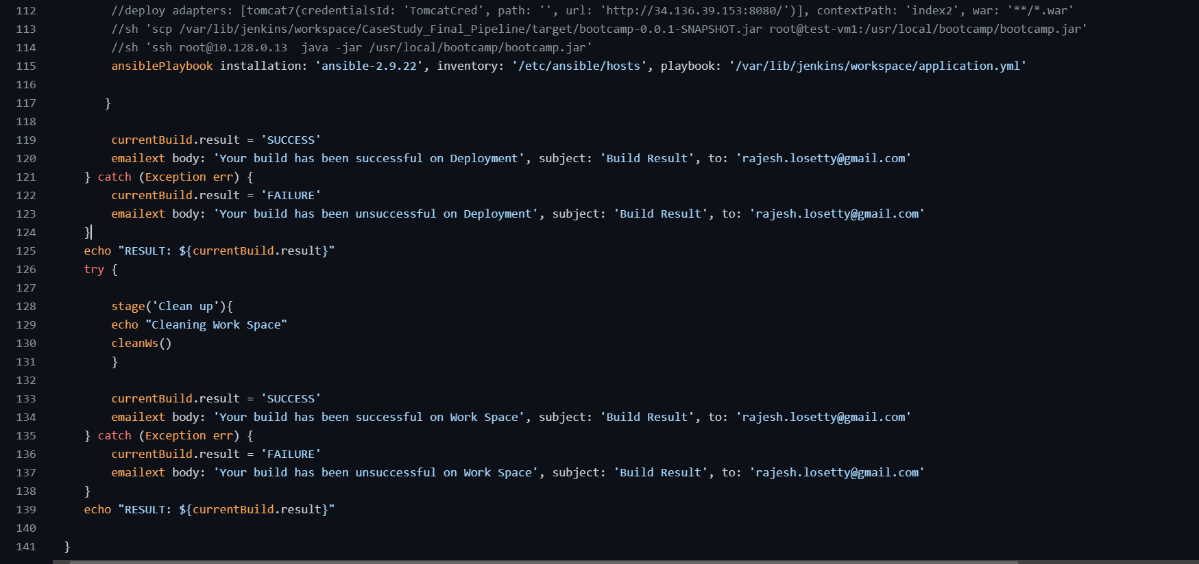

- Upload your Jenkins Log file in the Repo.(Complete log file should display your name on top).

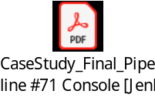

- Attach the screenshot of Jenkins pipeline job status. (All boxes should be green)

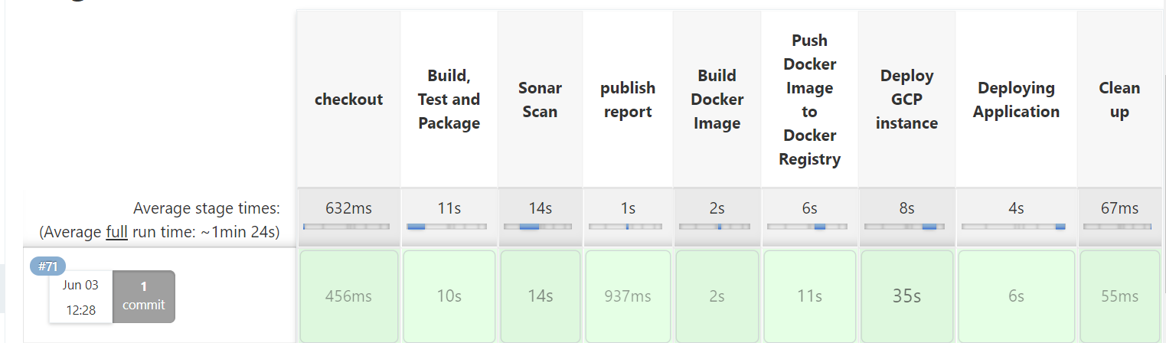

- Attach screenshots of email notification for the Jenkins build.

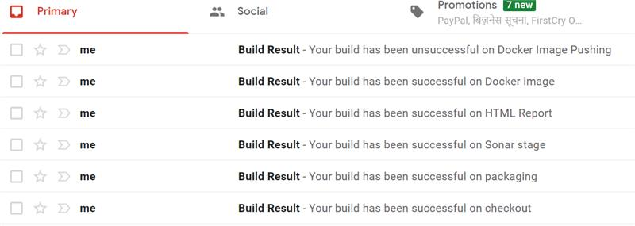

- Attach screenshot of the SonarQube Report.
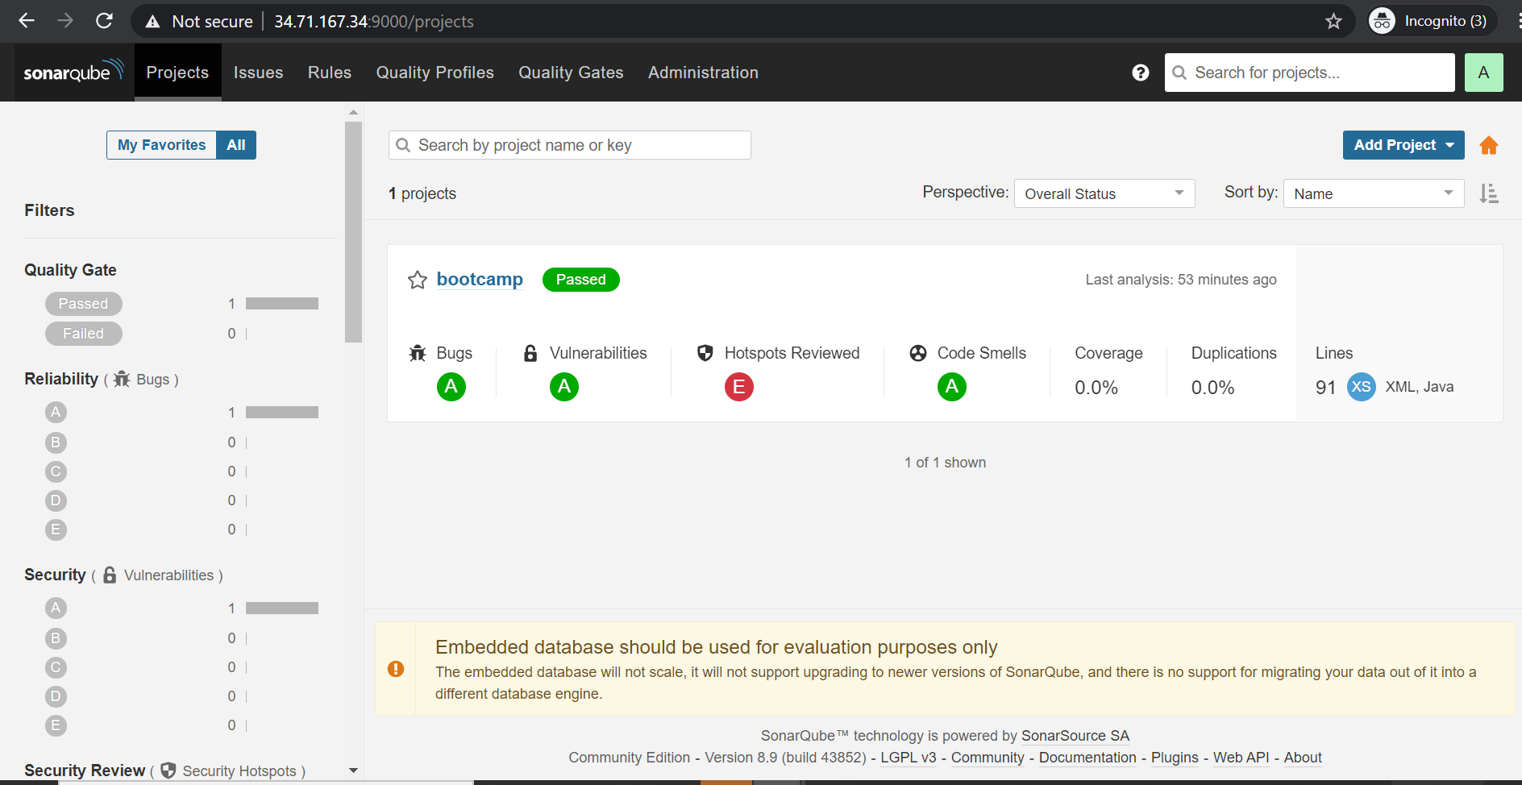

- Attach screenshot of the AppScan Report.

- Attach screenshot of your Ansible Playbook execution logs.

Deployment of Application:
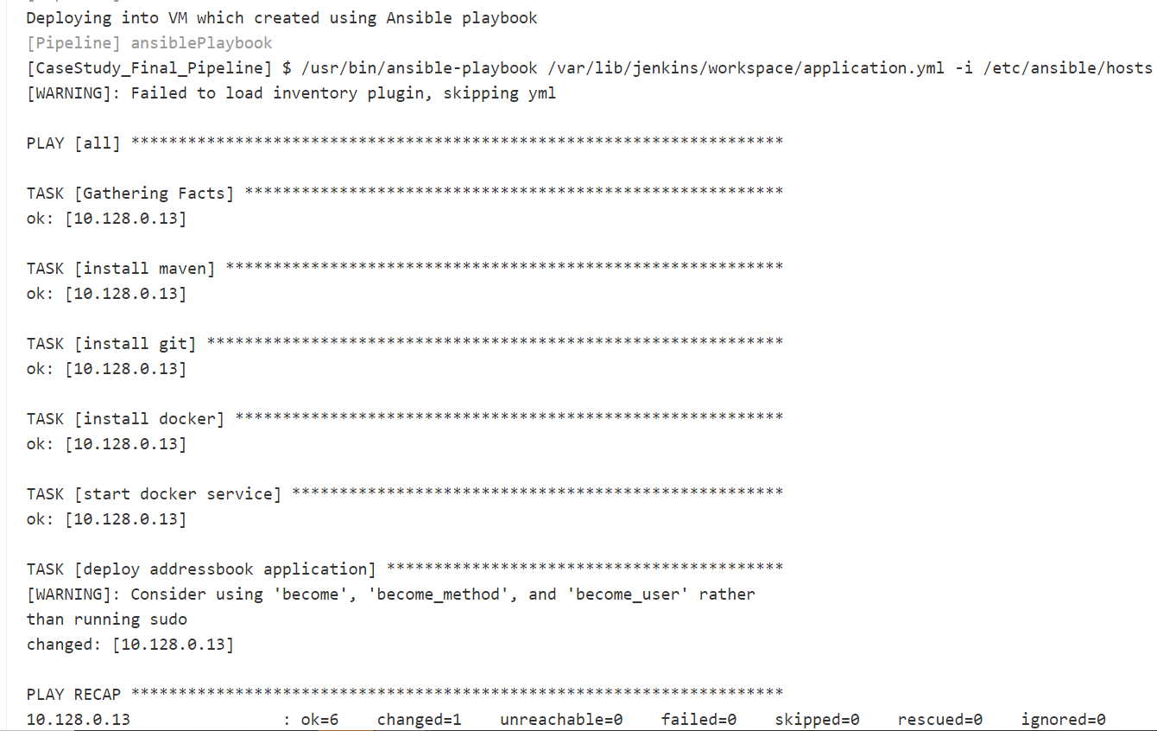

Deploy GCP instance using Ansible:
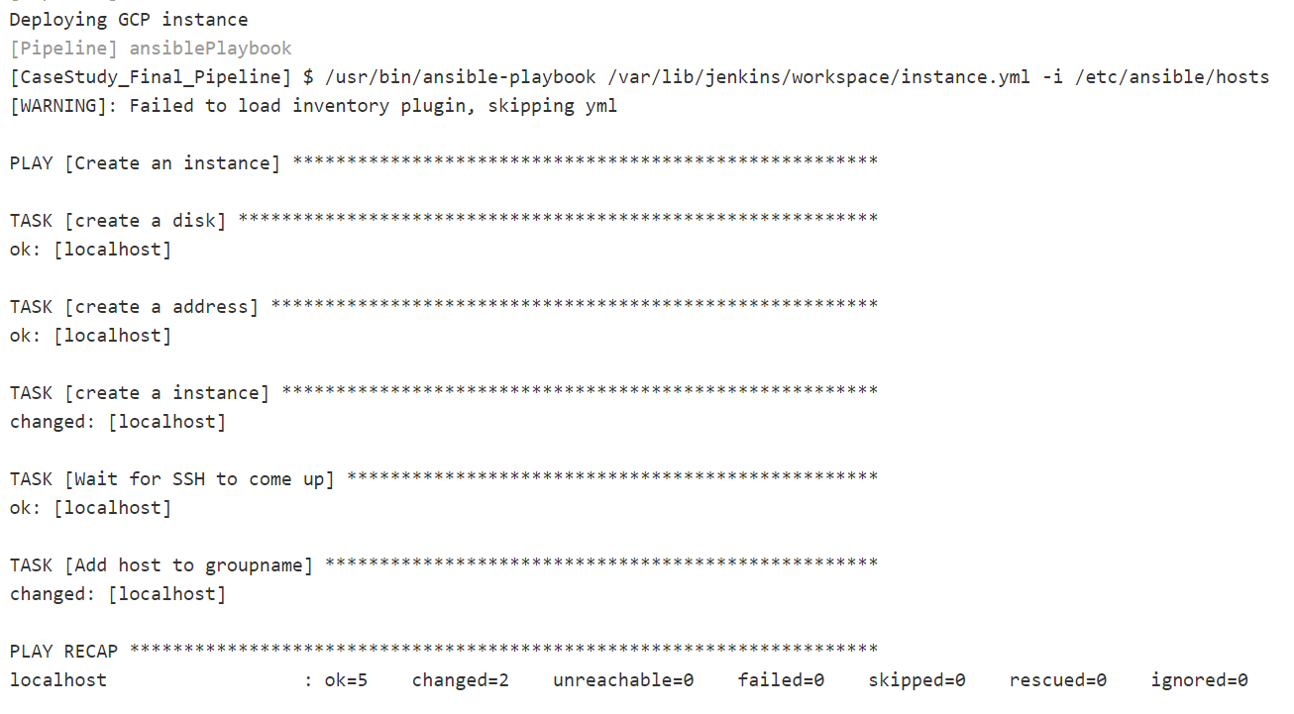

- Attach screenshot of the working application home page on AWS/GCP/Azure.

